Term Project: MobileNet

Design Document
Table of Contents
1 Introduction 2
1.1 Purpose and Scope 2
1.2 Target Audience 2
1.3 Terms and Definitions 2
2 Design Considerations 3
2.1 Constraints and Dependencies 3
2.2 Methodology 3
3 System Overview 4
4 System Architecture 6
4.1 User Account – Registering and Logging In 6
4.1.1 User Account - Database 7
4.2 Messaging – To All or One 7
4.2.1 Messaging – Holding Multiple Messages 7
4.3 Online users 8
5 Detailed System Design 9
5.1 User Account – Registering and Logging In 9
5.2 Online Users 9
5.2.1 Online Users – Message 9
5.3 Messages 10

Introduction
This documentation is to present an in depth outline of the design for MobileNet’s programming, which include architectural design and system design. MobileNet’s purpose is to give players access to the Blizzard community in the same familiar way, but on their mobile devices.

Purpose and Scope
The purpose of this document is to outline the thought process that is going through in the development of MobileNet and justify each software engineering methodology and choices that are being chosen for MobileNet.

Target Audience
The target audience for this document are Blizzard employees that have hired engineers to produce MobileNet, as well as those overseeing the future development and maintenance of MobileNet post production.

Terms and Definitions
Battle Tag: Blizzard’s own way of identifying their players and unique accounts. Battle tags come after the user’s username. An example of a username and battle tag is: Plinch#19327
UI: UI stands for User Interface
All chat: All chat is generally used for a place where all currently online users of said client can type into, and everyone else online can see it.

Design Considerations
This section will be a simple summarization of the thought process on how to approach MobileNet’s core development. Simply, what do we need to think about, and how can we approach that efficiently?

Constraints and Dependencies
One of the constraints that may hold back MobileNet’s production is the shortage of testers available to the team. MobileNet’s starting users is limited to those working on the project. Another constraint is that currently, the add friend function isn’t available, so to work around that, instead of having a designated friend/contact list, MobileNet will show online users that are using the app. Typing in an “all chat” would result in the instant message being shown to everyone online, and private messages will happen when the user chooses a user to message to. Much like how Overwatch works.
A dependency is that of MobileNet being coded with java in android studio, and working on android before IOS.

Methodology
The methodology being used for MobileNet’s production is the Dynamic Systems Development Model Methodology. The reason for this, despite having a single member on the team, is that this model focuses on the importance of the process, rather than the big goal. Reversible changes during development is key to making an app successful in the modern world, and with constant testing and communication between stakeholders, the app is ensured to be the kind of app it is expected to be. Frequent delivery of the product in different sections is being implemented with short steps, and constant testing of the program, structure, classes, and functions are being implemented constantly to ensure that the program will work.

System Overview
For MobileNet’s architectural structure, the core classes that will be created are the Login class, Login Request class, Register class, Register Request class, User Interface (UI) class, Online Users class, Online Users Request class, Messaging class, and Message Request class. These 9 classes each hold their own job and interact with each other in a way so that the app can flow between different instances, pages, and events.
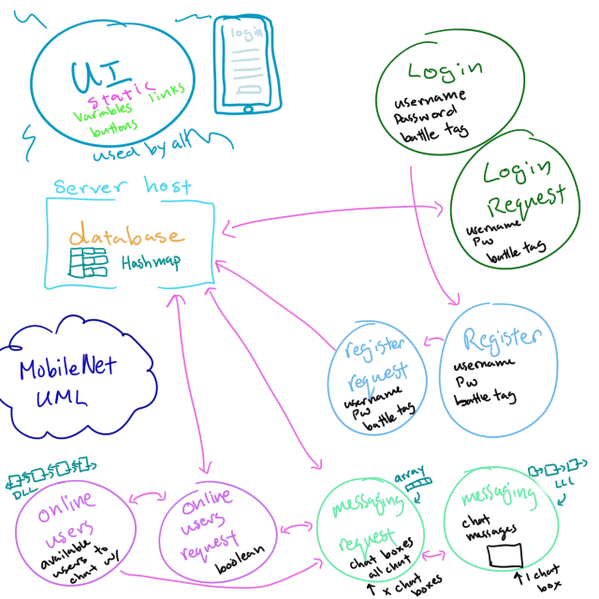
The classes with the word ‘Request’ in them handles the php files that communicate with the hosting server to retrieve or send information to the database. Login Request class would take in the users username and password and look through the database to see if such a combination exists in order to let the user log in. Register Request class handles the information being given by the user when they want to create a new account. The information is saved and sent to the database via the php file to create that instance of a user. The Message request class handles who the message is being sent to, whether it be to all online users, or to one specific user. The Online Users Request class has the job of determining whether or not a user is online or not, and creating them available to send messages to if they are online. This is done, much like the rest of the classes, by accessing the database.
The rest of the classes have basic functionality that corresponds to their class name. Login class holds member functions that enable the user to log in and press necessary buttons or links that are present in the log in page. Register class is similar except with a few more inputs needed. Message class enables the user to type messages and brings up the necessary chat boxes or pages when triggered. The Online Users class enables the user to click/tap on users. It is the essentially what the friends/contact list would be, just that there is no option to add or delete users, simply because it shows those who are currently online using the app. Finally, the User Interface class handles all the buttons and triggers the user may interact with. It is the class that declares all the variables for these triggers.

System Architecture
Each class is designed to have its own job, but some ‘jobs’ needed to be separated into two classes: Logging in, registering an account, messaging, and seeing who is online each have their own respective class, along with a secondary “request” class to its name. To put it short, those with the word “request” in the name handle communicating with the database to send or retrieve information needed to perform the necessary action. This section separates the architecture into different subsystems and components to explain how these classes work and interact with each other.

User Account – Registering and Logging In
The diagram below outlines the classes that are in charge of the registration and logging in process of the app.
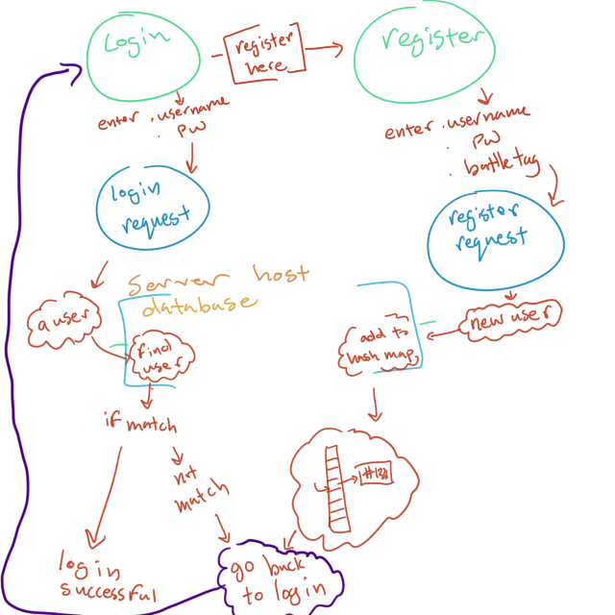
The User interface class is responsible for taking the user to different pages of the app. When the “Register Here” button is pressed, they are taken to the registration page, where the Register Request class takes the username, tag, and password to be sent to the database. From there, the User Interface class takes the user back to the log in page where they can insert their username and password. The Login Request class takes in the given data and checks through the database to check and see if the user exists (with the same username, and same password put together).

User Account - Database
The data structure of the database is that of a hash map. The data structure is developed to organize all the different users and make it easier for other class member functions to find a specific user. When registering, Blizzard identifies each user via a “battle tag”. This battle tag is asked to be given when a user wants to register account. In addition to a unique username, password, and a battle tag, the hash map can place this unique user into the data structure, as well as be retrieved by an algorithm to find that specific combination.

Messaging – To All or One
When a user wants to send a message, they have the option to either send to one specific user that is available to message, or to all available users. When given the latter option, the messages put into the “all chat” are placed in a linear data structure to hold all messages. In fact, the chat boxes are all very similar in that they hold messages in a linear fashion. The difference between the all chat and a personal message is that the all chat will show messages all on the left side, while the receiver of a personal message will see the text on the left, and their sent messages on the right.

Messaging – Holding Multiple Messages
In order to hold multiple different chat boxes within the app, an array will be used to hold a set amount of personal chat boxes, with the first one always being the all chat, and the rest being added or pushed off via the user.

Online users
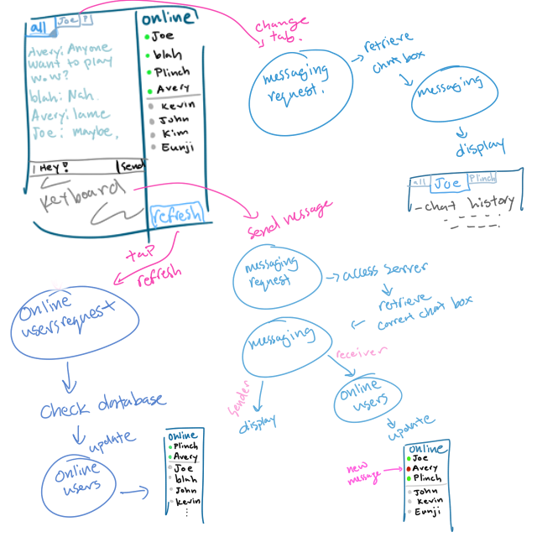
Whenever a user logs into MobileNet, their status is automatically changed to online. This enables them to be seen by all other online users currently on MobileNet. In order to keep track of who is online and offline to the users, a doubly linked list is on the top of the list in implementing the online users list for the app. The reason for this is because when a user comes online, they should be placed onto the list, but when they are offline, they need to be taken off. Users don’t typically come in an orderly fashion, so one user may come offline (and is in the second position), but there’s already 50 other users after them. The hash map of the database handles who needs to be taken off or placed on, but to place them onto a list in the app, a doubly linked list works best (so far) to place at the end, and take off the list, no matter where they may be (beginning, end, or in the middle). Below is a diagram that sums up section 4.2 – 4.3.

Detailed System Design

User Account – Registering and Logging In
When registering and logging in on MobileNet, the server holding the database is a third party online server. Because of this, a php file is needed for the program to communicate with the server and read all of its data. For that, the helper functions use simple algorithms to check and compare whenever necessary. When registering a new account, the new cluster of info for one account is created in the php file (Register Request class), saved, sent, and placed into the database. For logging in, a simple if and check statements are used to compare the given username and password, to those within the database. If found a match, then the user successfully logs in. However, if either a username or a password is unidentified within the database, the user will receive an error that will prompt them to try again.

Online Users
Helper functions used to check if a user is online will communicate with the server to check for online users and send feedback to the apps online user list. Functions such as add, remove, retrieve, and remove all are necessary for the online user list. A button/function called “refresh” will be added in order for the user to refresh the list and see who else has come online or gone offline. Functions associating with this class also interact with the Messaging class to open chat boxes as well.

Online Users – Message
Whenever a message is sent directly to a user (personal message), the online users list will indicate that user of a new message. The Messaging class has an add, remove, retrieve, and remove all function, much like the Online Users class, so that the chat boxes may be added, removed, or opened. When a user logs off, the chat boxes will be closed, however stored separately, the messages from a conversation are saved and can be reopened and viewed at any time.

Messages
Messages sent and received, except in the all chat, are saved onto the server so that users can review old personal messages far into the future. Each conversation created an instance of a linear linked list, and for each message sent, that block of text is added to the beginning of the data structure. The only real function needed is an add function, whereas a display function for each class is heavily implied so that the users can see what they need to see.

